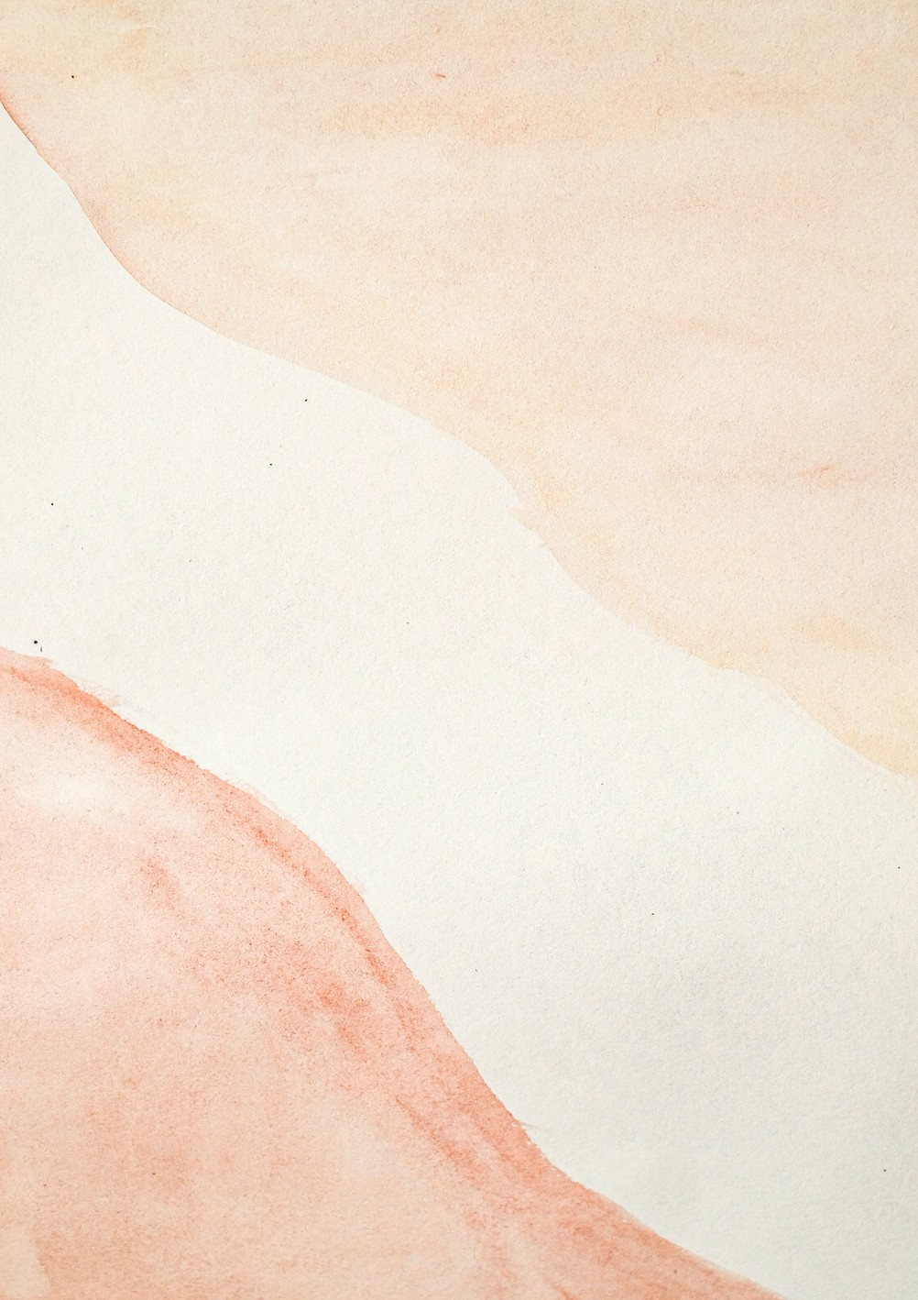Coca-Cola Beverages South Africa (Pty) Ltd

|  |  |  |  |  |
| --- | --- | --- | --- | --- |
| **To: Bigen Africa Services (Pty) Ltd** | **Date:** 06/12/2022  **Invoice#: INV_020671Va**  **PO # : 'PO No-00041972**  **I N V O I C E** | | |  |
| DESCRIPTION | PRICE QTY. | | | AMOUNT |
|  |  |  |  | |
| Black Pens | R 250.42 | 113  Total | R 2024.21  R 2024.21 | |
| Total Tax 10% |  | |
| **Grand Total** | R687183 | |
|  | | | | |